School of Psychology and Neuroscience

What colour is this dress, and more importantly, why is everyone so confused by it?

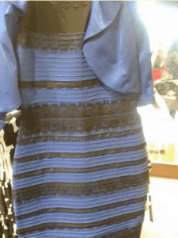
What colour is this dress, and more importantly, why is everyone so confused by it?
By Thibaud Vanderschrick
The original picture of the dress
If you were using the internet in February 2015, chances are you have seen this dress and maybe you have even discussed it thoroughly with friends and family. The image looks innocent enough in isolation but if you were to ask a room full of people what colour they think it is, you might be surprised to find the multitude of different answers you will get. Lafer-Sousa and colleagues found that 57% of people see the dress as blue and black, 30% see white and gold, 11% see blue and brown, and 2 % see something else entirely.

What really stands out with this image is that it seems to behave differently from conventional visual illusion. A lot of visual illusions that we come across are not completely stable meaning that if we try, we can see it another way. An example of a non-stable visual illusion called Rubin’s Vase was explained by William H. Ittelson and appeared in Schooler’s 2015 paper. At first glance you might see a black vase on a white canvas, or two white-faced silhouettes staring at each other with a black background. In this illusion regardless of what you see first, you can still easily identify the counter image and thus see both. This is not the case with the dress, where the effect at play is stable in most people, most either see blue and black or white and gold. This is what prompted such widespread debate over the dress since it is impossible for people to see it both way and thereby difficult to understand how others could see it differently.
Rubin's Vase

First and foremost, the truth of the matter is that the dress is black and blue which was verified by the retailer selling the dress, so, problem solved right, half of the people just see the wrong thing. While it would be possible to leave it at this, it is not a very satisfying conclusion, especially for all those people who see the dress as white and gold. It is in concerning ourselves with the why, that we can explore and learn about how and why we humans perceive colour the way we do.

The answer to the why question lies in what psychologists studying the visual system call Colour Constancy. To understand the ambiguity of the dress there are 2 main principles that need to be understood.
Firstly, the colours we perceive do not occur in isolation, they are dependent on the brightness, and colour of their surroundings. Looking at brightness first, as shown in the image below, the same grey square appears darker when placed against a light background, and lighter when placed against a dark background, this is known as brightness contrast.
Hering's (1878) demonstration of brightness contrast as shown in Spillmann’s 1999 paper.

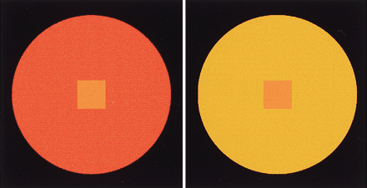
The way that surrounding colour impacts our perception of object colour works in a very similar way to how brightness impacts it. This image is taken from Lotto and Purve’s 2000 paper about colour contrast and shows that the same shade orange square looks different depending on the colour of the background it is put against. This is known as colour contrast. You might be wondering why this occurs, why does the brain bother using the surroundings to identify the colour of our target (what we are interested in)? This seems like a great deal of extra processing and the gain seems non-existent since it functions to make us see colors differently depending on the surroundings. The answer to this can be found by understanding the second principles.
Image showing the colour contrast effect from Lotto and Purve’s 2000 paper.
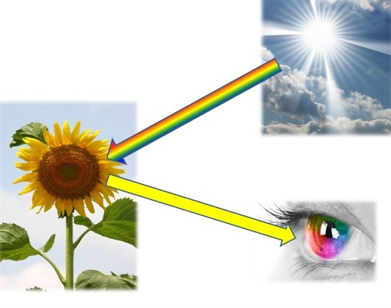
Secondly, as Gegenfurtner and his colleagues pointed out in their 2015 paper about this very dress, colour is not solely reliant on the object we perceive. Rather, as indicated in the diagram, when we see an object, light from a source (such as the sun or a lamp) hits the object first before reflecting off it into our eyes. What is important about this is that the light that reaches our eyes, the information we see, is not is based on both the object AND the light source.
Colour perception diagram

This explains our need for background colours and shades as a frame of reference for our colours because otherwise, depending on the light source we have, the same object might appear to be a completely different colour. For example, the light from the sun is very different to the light from a lamp, its composition (the wavelengths within it) are very different. So, if we saw object colour in isolation (if colour/brightness contrast hypothetically speaking did not exist) then the same apple would appear a different colour in a windowless room (with a lamp as a light source), than it would outside (with the sun as a light source). This is the use of colour constancy, it allows us to see the same object as being the same colour, regardless of the light source.

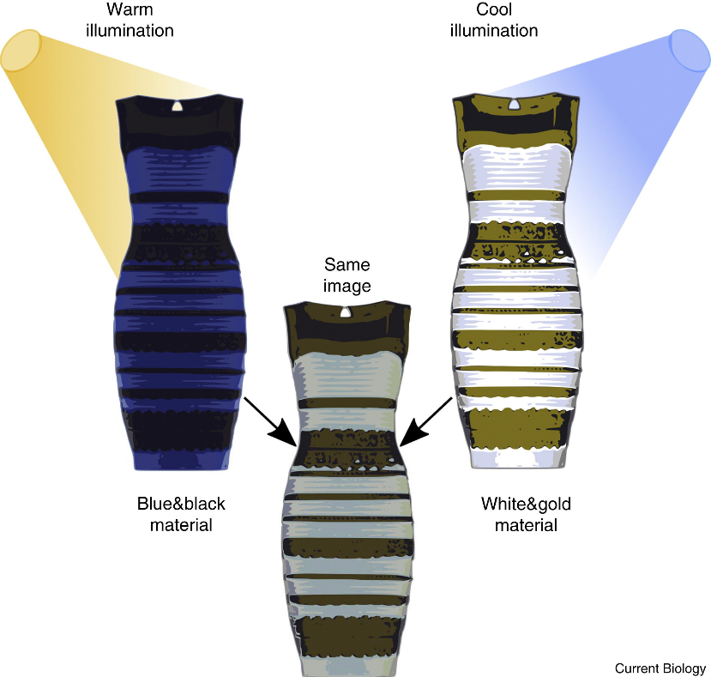
This brings us back to the dress. As David Brainard and Anya Hurlbert describe in their 2015 paper, the reason people see different colours is because the brain has a hard time interpreting the lighting with the limited information it receives from the image. As a result, the brain has to guess, and depending on that, people predominantly either see blue and black, or white and gold. If the brain interprets a warm artificial light source, it sees the dress as a blue and black. If the light source is conversely interpreted as a cool natural light (from a nearby window for example), then we see a white and gold dress.
Image explaining how we interpret the dress based on light source from Brainard and Hulbert’s 2015 paper.

The dress is one of many examples in which ambiguous lighting can result in strange colour perception and the science behind it is still being researched.
References:
Brainard, D. H., & Hurlbert, A. C. (2015). Colour vision: understanding# TheDress. Current Biology, 25(13), R551-R554.

Gegenfurtner, K. R., Bloj, M., & Toscani, M. (2015). The many colours of ‘the dress’. Current Biology, 25(13), R543-R544.

Lafer-Sousa, R., Hermann, K. L., & Conway, B. R. (2015). Striking individual differences in color perception uncovered by ‘the dress’ photograph. Current Biology, 25(13), R545-R546.

Lotto, R. B., & Purves, D. (2000). An empirical explanation of color contrast. Proceedings of the National Academy of Sciences, 97(23), 12834-12839.

Schooler, Jonathan. (2015). Bridging the Objective/Subjective Divide Towards a Meta-Perspective of Science and Experience. In T. Metzinger & J. M. Windt (Eds). Open MIND: 34(T). Frankfurt am Main: MIND Group. 10.15502/9783958570405.

Spillmann, L. (1999). From Elements to Perception: Local and Global Processing in Visual Neurons. Perception. 28. 1461-92. 10.1068/p2763.

Images not taken from papers have been hyperlinked to their source webpages.

