Colour Constancy
Learning intention: Introduce the phenomenon of colour constancy through colour illusions. Colour constancy will be demonstrated through the design of a Mondrian that the pupils will conduct a small experiment with. At the end of the lesson, the pupils should be able to explain colour constancy in the context of #thedress.
Learning Objectives
- Describe the concept of colour constancy
- Design their own Mondrian to explore colour constancy in practice
- Discuss colour illusions and what they tell us about colour perception
Essential materials
- A printed copy of worksheet A
- Colouring pencils/pens/crayons
- An artificial light, such as a lamp
Optional material
- A printed copy of worksheet B
****************************************************************
Introduction to Colour Constancy
- Colour constancy is a psychological phenomenon where the colour of objects appears the same even when the lighting conditions change.
- The basic colours in the visible spectrum, the colours we can see, are red, yellow, green, blue, indigo, and violet.
- The colour of an object depends on the colour of light it absorbs and reflects.
- Light sources can be coloured, which changes the colour of light that the object reflects.
- We experience many lighting conditions, from the white light of the sun to the warm artificial light of lamps, but objects viewed under these different conditions will appear the same colour due to colour constancy.
- Without colour constancy, it would be very difficult to recognise objects.

****************************************************************

Colour Illusions: Testing Colour Constancy
Questions:
- What colour is a strawberry?
- Now, what is the colour of these strawberries?
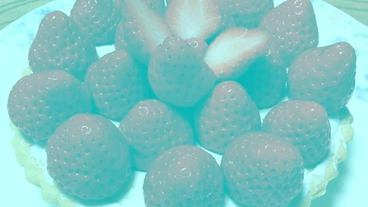
You might say that these strawberries are red, but there is actually no red in the picture. The strawberries in the picture are actually grey

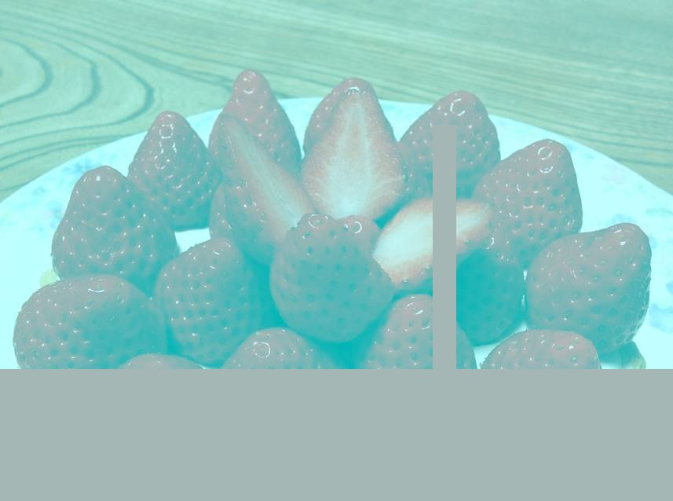

You might be able to see that the strawberries are grey when we add a grey box for comparison.
If you still cannot see the grey, that is okay. Our perception of colour is not perfect. Your brain can and will make mistakes when you try and identify colours.

An Explanation of Colour Constancy
When you look at this picture your mind will think that the lighting in the image is blue. When your brain thinks the light is coloured, it will mentally take away that colour from the colour of the object.
Grey - Blue = Red
− =

Additionally, our perception of colour is affected by our knowledge of the objects we see. We all know that strawberries are red, so when we see a picture showing the shape of strawberries, our brain makes us perceive the colour we associate with them.

These concepts are further explained in this video: Why Your Brain Thinks These Strawberries Are Red | Science Of Illusions | WIRED - YouTube

Scientists like to use these illusions to study colour perception.

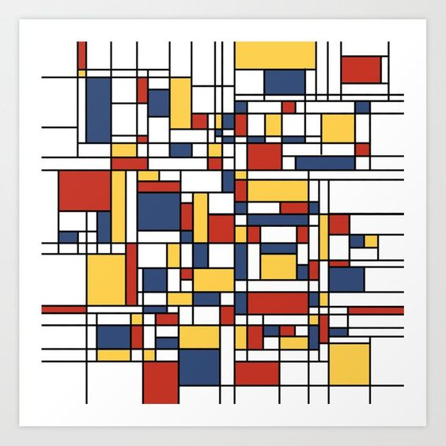
Mondrian Task Instructions
The most famous colour illusion used to study how our brain sees colour was based on the art of Piet Mondrian. Piet Mondrian was an artist from Holland who was known for abstract paintings. He made his paintings by combining lots of squares and rectangles of different sizes and colours. Today you will be taking inspiration from his art in order to conduct your own colour experiment.
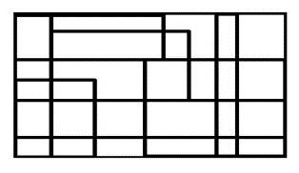
For this task you will need:
- The printout of the Mondrian design (Resource A)
- Coloured pencils/pens/crayons
- Your hand
- A lamp or other artificial lighting
Instructions
Step 1 – Colour in the Mondrian design. Piet Mondrian mostly used the three primary colours (red, blue, and yellow) but you can use any colours you want.
Step 2 – Take your coloured Mondrian picture and examine it under different types of light. Make a note if you see any changes or if the colours stay the same.
Natural light – Turn off the light and go over to a window.
Shadow - Place your hand above the picture to create a shadow
Artificial light – Place the picture under a lamp or artificial light
Discussion for Main Task
- You should have experienced colour constancy, the colours in the Mondrian picture should have looked the same under each lighting condition.
- For example, when the picture was shaded, your brain should have ignored the shade to see the colours the same as you would in direct light.
- In summary, colour constancy is a trick that the mind uses to make the colours of objects appear the same even when the lighting changes.

The optional task can be completed as a plenary task or as homework.
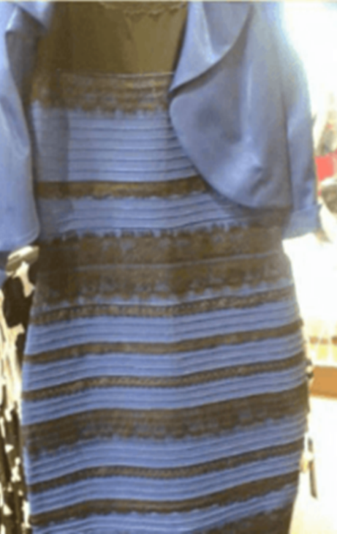
Discussion for Optional Task
- This dress prompted a wide conversation about colour constancy and the different ways people see colour. The actual colour of the dress is blue and black, but many people see the dress as white and gold.
- Scientists have hypothesised that the dress can be interpreted as white and gold when the brain assumes that the dress has been pictured in daylight or it assumes that the dress is under a blue shadow, which would make the white and gold appear darker.
- If you see the dress as black and white, your colour perception is accurate. Your brain is correctly assuming that the dress is under a bright artificial light which is washing out the blue and making the black appear brighter.
- Scientists are still unsure why the dress is seen so differently. They think it might be influenced by your age, gender, and even your sleeping pattern. However, they are still not sure exactly how these factors influence our perception of colour or why the image of this specific dress was so effective at exposing these differences.
- There is still a lot to learn about colour and colour perception is a growing field of research in psychology.
- These concepts are covered well in this video: What Colour Is This Dress? (SOLVED with SCIENCE) - YouTube
Resources
Worksheet A
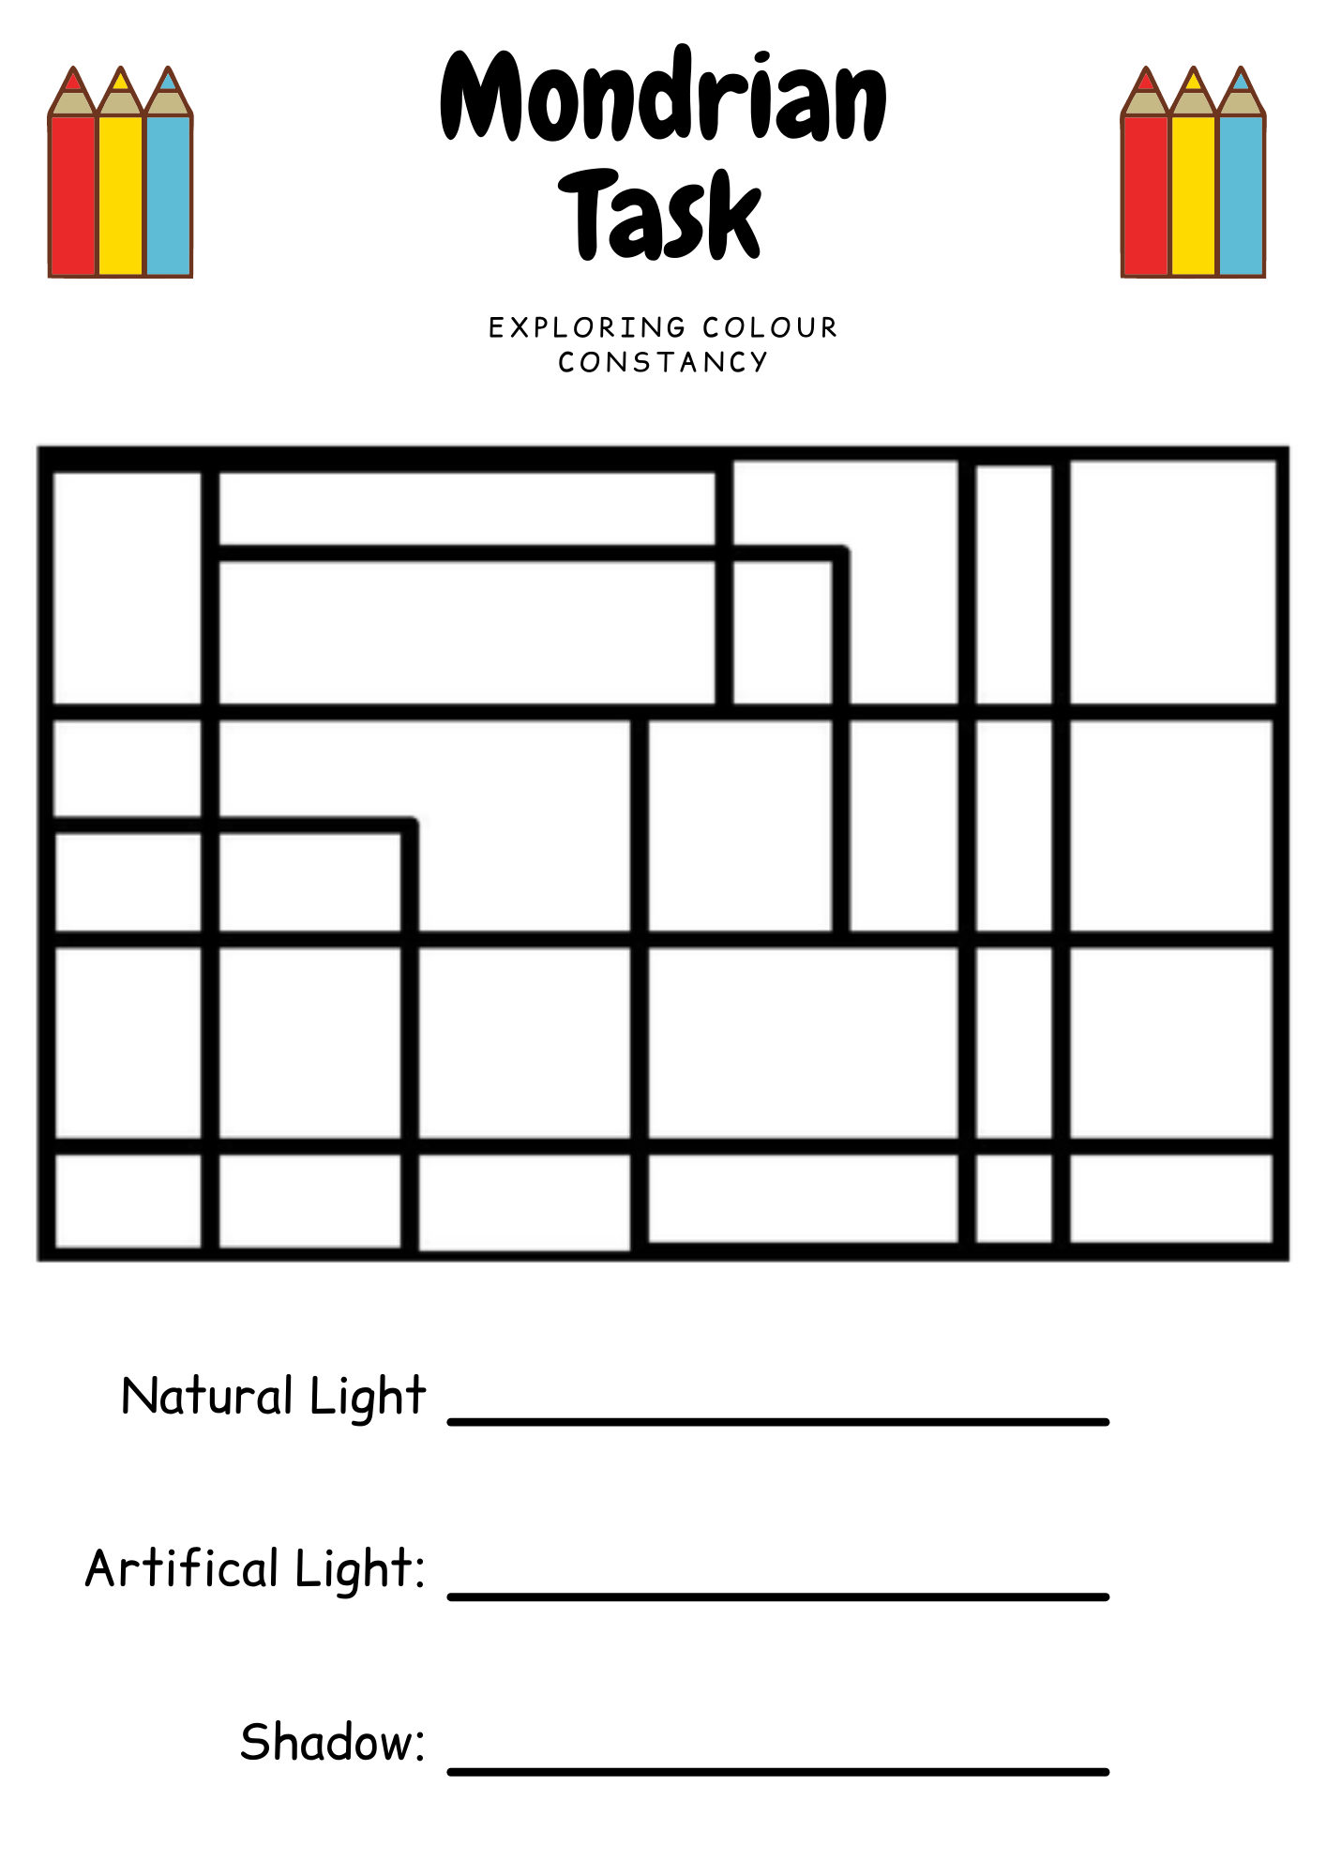
Worksheet B
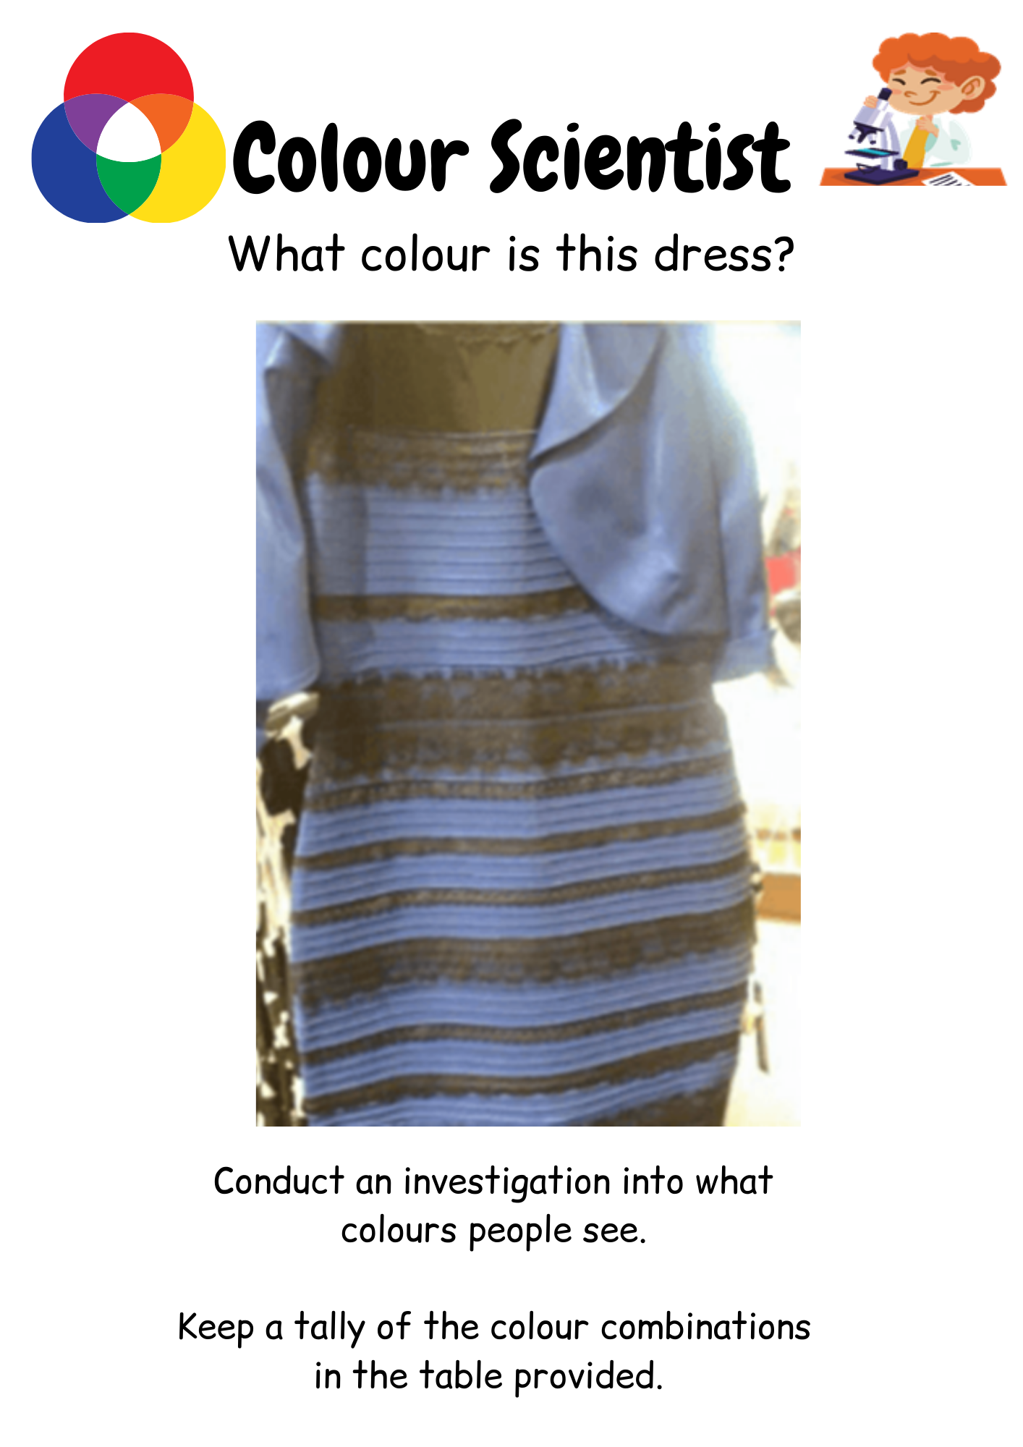
Pg. 1/2
Gold and White |  | Blue and Black | Other

Discussion
Now that you have collected everyone’s answer, reveal the true colour of the dress (blue and black).
Try to explain why they might see different colours using your new understanding of colour constancy.
Feel free to use materials provided to you in your science lesson.

Pg. 2/2

References
BBC Bitesize. (2021). What is colour? Retrieved from https://www.bbc.co.uk/bitesize/topics/zw982hv/articles/z7rtng8
Brainard, D.H. & Hurlbert, A.C. (2015) Colour vision: Understanding #TheDress. Current Biology, 25(13), R549-R568. doi: 10.1016/j.cub.2015.05.020
Education Scotland. (2017). Benchmarks Sciences – Education Scotland. Retrieved from https://education.gov.scot/nih/Documents/SciencesBenchmarksPDF.pdf
Hutton, J. [@_tim_hutton_] (2017, February 28). I drew three rectangles on top to also show the effect. IMAGE: https://pbs.twimg.com/media/C5w91AZXQAAU9k3?format=jpg&name=900x900 [Tweet]. Retrieved from https://twitter.com/_tim_hutton_/status/836611814096060416
Rabin, J., Houser, B., Talbert, C. & Patel, R. (2016) Blue-Black or White-Gold? Early stage processing and the color of 'The Dress'. PLoS ONE, 11(8), 1-10. doi: 10.1371/journal.pone.0161090
Rogers, K. (2017, February 28). This picture has no red pixels - so why do the strawberries still look red. Retrieved from https://www.vice.com/en/article/wnkq5n/this-picture-has-no-red-pixelsso-why-do-the-strawberries-still-look-red

Photo credits
Worksheets created using: www.canva.com
Clipart from ClipartLibrary: http://clipart-library.com/search2/?q=scientist#gsc.tab=1&gsc.q=scientist&gsc.page=5
Pinterest (2021). Mondrian De Stijl Pattern Art Print. Retrieved 22 February 2021, from https://www.pinterest.co.uk/pin/114560384259711598/?d=t&mt=login
Piet Mondrian Art Resource from: https://www.tes.com/teaching-resource/piet-mondrian-6024493

