School of Psychology and Neuroscience

Inverted Face effect and Thatcher Illusion

Introduction:
In the Seoul’s upside-down cafe, there are mannequins of famous celebrities, pool table, vase, drinks and familiar office objects in an inverted orientation. One noticeable phenomenon is that it was easier to recognize the upside-down objects than upside-down faces. Indeed, with five celebrities in a visually chaotic scene, it took a while to recognize who is who. Another layer of this strangeness in recognition was added when it was shorter in time to find the colleague than recognizing mannequins’ faces in this crowded café environment. It was fascinating to find out that this is a psychological phenomenon of visual orientation, which brings different theories of visual processing into one table. This brings to the main question of the paper: what is the different visual processing involved in this illusory phenomenon and why?
Thatcher Effect:
Motivated by this question, this group of students present the explanation in regard to famous inverted face effect – ‘Thatcher Effect’ – demonstrated by Thompson (1980). The inverted face effect was initially suggested when Gestalt psychologist Köhler (1940) discovered that upside down faces is harder to recognize than upright faces. Following this idea, inverted face effect was examined in various angles, such as difference in visual processing by cognitive psychologist Treisman and Gelade (1980), difference in reaction time for processing inverted face by cognitive scientist Shepard and Metzler (1971) and difference in memory retrieval for upside down face by social scientist Yin (1969). The core idea is that it has a longer reaction time, and more cognitive burdens for processing an inverted face than an upright face. Extending this idea, perception psychologist Peter Thompson (1980) examines if human can detect the difference when eyes and lip are inverted as well in an inverted face of Margret Thatcher (known as ‘Thatcherized’). In conclusion to Thompson’s investigation, the change of eyes-lip’s orientation in an inverted Thatcher image is not as obvious as when the image is in upright orientation while Thatcherized image after presented upright is perceived to be grotesque and unusual (See Figure 1).
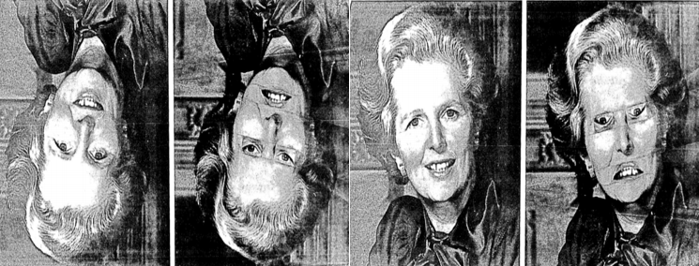
Figure 1: Inverted and Upright images of Margret Thatcher from Thompson (1980). 1st and 3rd photo represent face without a change, 2nd and 4th photo represent face that is ‘Thatcherized’.
As cognitive psychologist Adachi and his colleagues (2009) from Kyoto University summarize, Thatcher effect (or Thatcher illusion) shows that it is difficult for human brains to find changes in the position of eyes and mouths when an image of face is inverted. Considering the difficulty of perceiving the difference in ‘Thatcherized’ photos, it is possible to deduce that there is different visual processing involved. In an upright condition, it is suggested by clinical psychologist Ellis (1975) that humans use characteristics of faces to detect face and emotions. Then, how does this processing change when face is inverted along with these characteristics? The next section provides different theories around Thatcher effect to explain the change in visual processing of face recognition.
Configural Hypothesis:
Suggested by Freire and her colleagues (2000), upright face is processed in two stages. First, human visually perceive configures of a face, such as proportion of eyes to nose to lips, to form a holistic representation of a face. Then, this holistic representation is used to distinguish the face to others, and hence the face recognition. However, in an upside down condition, Freire and her colleagues discovered that brain uses both face region (Fusiform Face Area) and object / place region (Occipital Face area and Parahippocampal area) to process face recognition, which induces greater reaction time in recognizing upside down face. This indicates that when the face is upside down, cognitive burden comes from the attempt of the brain to use both face and object recognition in encoding visual information. Following this, as cognitive psychologist Bartlett and Searcy (1993) claim, these configural information become unavailable when the face is Thatcherized. Precisely, brain is cognitively burdened at the stage of inverted face, thus there is a lack of cognitive capacity which makes it more difficult to distinguish between Thatcherized photos and un-Thatcherized photos in an inverted condition. In conclusion, the lack of cognitive capacity leads people to focus more on the global representation of a face rather than configural features of a face.
Schematic Hypothesis:
Schema is suggested to play an important role in human cognition, including awareness and recognition. As social psychologist DiMaggio (1997) suggest, schema is a framework of individual’s knowledge that provides a shortcut to cognition. In the light of the schema, it is possible that individual is more used to processing upright face than inverted face, which adds a layer of difficulty to detect any featural distortions in an inverted face image. Indeed, as perception psychologist Collishaw and Hole (2002) suggest, novelty and unfamiliarity of perceiving inverted face image led to a difficulty in processing inverted face, and hence tendency to process global attributes rather than features. This explains why Thatcherized photos are harder to recognize the difference, that human schema is unfamiliar with processing inverted face, thus it changes processing from featural recognition to holistic recognition.
Interesting points about Thatcher Effect:
One interesting point about Thatcher effect is discovered by Adachi and his colleagues (2009). They discovered that Thatcher effect is shown in Rhesus monkeys, which provides an evolutionary evidence to the different facial recognition processing. The fact that primates perceive this illusion shows that facial recognition is an important process for species with sociality.
Another interesting point is Thatcher effect in prosopagnosia. Prosopagnosia is a face blindness that one cannot perceive the facial features (See Figure 2). Despite the deficit, patients with prosopagnosia could distinguish the difference when Thatcherized face is presented upright through processing global attributes of faces. This indicates that human has different modes of visual processing of faces.
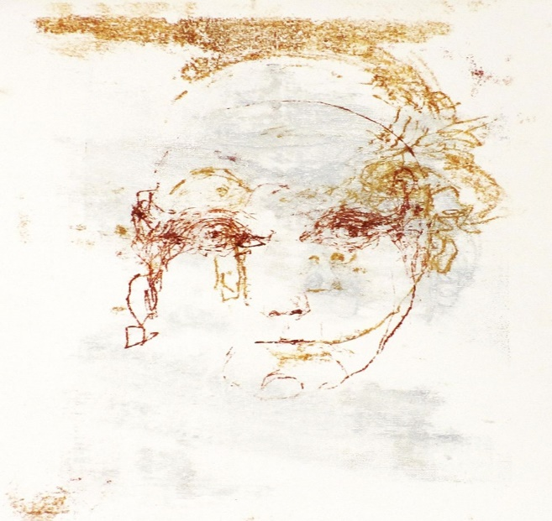
Figure 2: Drawing of how person with prosopagnosia see the face (Venema, 2020)
Conclusion:
In conclusion, Thatcher effect not only demonstrates the cognitive difficulty in processing inverted face, but it also shows different mode of visual processing such as global processing and featural processing. This provides an interesting ground to the study of facial recognition by providing an opportunity to test different perceptual theories. The author believes that the topic is relevant to real-life application of psychological phenomenon and hopefully attract young people into scientific research.

References:
Adachi et al. (2009). Thatcher Effect in Monkeys Demonstrates Conservation of Face Perception across Primates. Current Biology, 19(15), 1270-1273. Doi: 10.1016/j.cub.2009.05.067
Bartlett, J. C., & Searcy, J. (1993). Inversion and configuration of faces. Cognitive Psychology, 25(3), 281–316. https://doi.org/10.1006/cogp.1993.1007
Collishaw, S. M., & Hole, G. J. (2002). Is there a linear or a nonlinear relationship between rotation and configural processing of faces? Perception, 31(3), 287–296. https://doi.org/10.1068/p3195
DiMaggio, P. (1997). Culture and cognition. Annual Review of Sociology, 23, 263–287. https://doi.org/10.1146/annurev.soc.23.1.263
Ellis, H. D. (1975). Recognizing faces. British Journal of Psychology, 66(4), 409–426. https://doi.org/10.1111/j.2044-8295.1975.tb01477.x
Freire et al. (2000). The Face-Inversion Effect as a Deficit in the Encoding of Configural Information: Direct Evidence. Perception, 29(2), 159-170. Doi: 10.1068/p3012
Köhler, W. (1940). Dynamics in psychology. Liveright.
Shepard, R. N., & Metzler, J. (1971). Mental rotation of three-dimensional objects. Science, 171(3972), 701-703. Doi: 10.1126/science.171.3972.701
Thompson, P. (1980). Margaret Thatcher: A new illusion. Perception, 9(4), 483-484. Doi: 10.1068/p090483
Treisman, A., & Gelade, G. (1980). A Feature-Integration Theory of Attention. Cognitive Psychology, 12(1), 97-136. Doi: 10.1016/0010-0285(80)90005-5
Venema, V. (2020). Prosopagnosia: The artist in search of her face. Retrieved from https://www.bbc.co.uk/news/stories-53192821
Yin, R. K. (1969). Looking at upside-down faces. Journal of Experimental Psychology, 81(1), 141–145. https://doi.org/10.1037/h0027474

