How we make sense of our senses...
Aims and objectives
A reflection on what your senses are and what they do.
Going beyond the five – ‘balance’ a new sense.
From senses to perception. Your brain is the boss.
Optical illusions trick our brain.

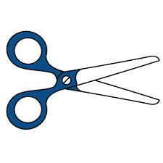
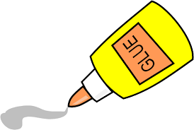
You’ll need: 3 pieces or paper; colouring pens and a pencil; tape or glue.
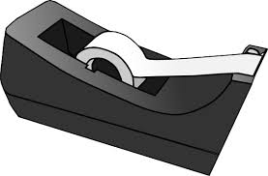
What do you already know?
Write down 3 facts you already known about the brain and the senses.
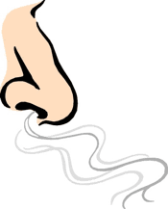
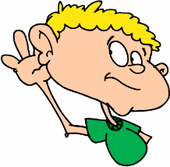
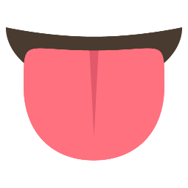
The 5 senses

Vision – We see with our eyes.
Sound – We hear with our ears.
Smell –We smell with our nose.
Taste – We taste with our tongue.
Touch – We touch with our hands. But we can touch with other parts of our body too! Think about kicking a football!

What do these senses have in common?
All the sense we have just talked about collect information about the outside world. Now, write down how you’d describe and apple. You don’t just describe it using one sense, do you? The senses work together, and the brain is in charge!

A new sense – balance –
Time for some movement. Can you do this pose?
The sense working hard for you right now is balance. You have probably heard the word balance before but how does it work? The body uses your inner ear, your eyes, your muscles, your joints, and your brain to figure out your position in space, and keep you in the position you are telling your brain you need to be in. Balance is part of a wider system called the proprioceptive system. The ear is for more than just hearing! There is a special system attached to the ear called the ‘vestibular system’, and it sends information to your brain’s movement control centre ‘the cerebellum’ about where your head is. Unlike the other senses we have just talked about balance is not clearly associated with one specific body part. It takes information from lots of different parts and the brain and pieces it together. Because all the parts are working together, does this sound more complicated than the other senses? But think about it – our senses work together all the time!

Did you know?
It is not just balance that has a special part of the brain linked with it. All your senses do! But what happens when your senses don’t work in the typical way? The brain is very flexible so when blind people read braille with touch, the same part of their brain is used when people who have sight read words with their eyes.

Eyes shut origami dog
- Start with a square piece of paper (cut your A4 if you need to).
- Shut your eyes.
- Fold the top corner of your square paper to the bottom corner. The paper should be in half.
- Fold the left corner to the right corner. The paper should now be in a triangle.
- Unfold the triangle. But the paper should still be in half from the first step.
- It’s time to make the dogs ears! Fold both corners of the triangle down to make the ears.
- For the chin, fold the last corner of the triangle the opposite way from the ears.
- Now grab your pencil. Give your dog some eyes and a nose.

What senses did you use for this task?
Hearing and touch work together to follow these instructions. The picture of what is going on and what needs to be done is put together by the brain.

What is perception?

Perception is simply how the brain builds the whole picture of the world around us.

How is perception like baking a cake?
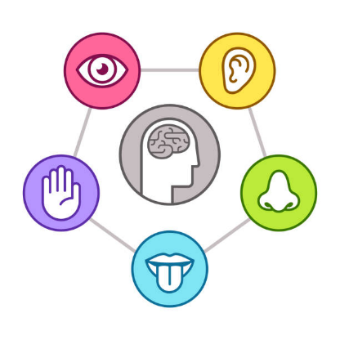
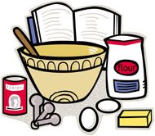
Just like senses, the eggs, milk, flour, and sugar are the ingredients. The whole cake is the final picture. The oven and the mixing are like your brain. The brain is the part of our bodies that brings all our sense ingredients together and makes it understandable to us. Just like the difference between the cake batter and the cake itself – the initial sensory ingredients are different from the final product of perception. The brain bakes a cake of the world.

How do we understand the baking of the cake?
To understand the cake, you need to understand the ingredients but also the oven and mixing itself. Psychology is the science that investigates how the brain bakes the cake. It wants to answer questions about how the brain arranges the outside ingredients to form the picture in our heads. One way that we can understand how our brain organises things is by messing with the ingredients. Optical illusions have been used by psychologists to mess with our senses and see if we can trick the brain’s building of the picture of the world. Why do we want to trick the brain? By tricking the brain psychologists can deduce how organisation systems in the brain work.

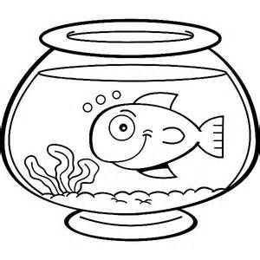
Fishbowl Illusion
- Cut out two equally sized squares from a sheet of paper.
- Draw some fish on one side.
- On the other side draw a fishbowl.
- Glue or tape a pencil between the two drawings.
- You now have your illusion! Hold the pencil between your palms. By rubbing your hands, it will look like there is one picture – the fish in the bowl.

Why does it look like the fish are in the bowl?
When you spin the pencil, your brain sees one image and before it has figured out what it is, it sees the image on the other side. So, it is like two images are seen at the same time. This is an effect called persistence of vision. Persistence of vision can be simply understood as an after image, it means something can look like it is still there after it isn’t.
What have you learnt?
What do you know about balance? Can you use your origami dog and your illusion to explain to your household how our senses work together in perception?
Bibliography –

(2021). Retrieved 10 March 2021, from https://www.bbc.co.uk/bitesize/topics/z9yycdm/articles/zxy987h

AQA GCSE Psychology Perception Revision Notes | Learndojo. (2021). Retrieved 10 March 2021, from https://learndojo.org/gcse/aqa-psychology/perception/

Burton, H., Snyder, A., Conturo, T., Akbudak, E., Ollinger, J., & Raichle, M. (2002). Adaptive Changes in Early and Late Blind: A fMRI Study of Braille Reading. Journal Of Neurophysiology, 87(1), 589-607. doi: 10.1152/jn.00285.2001

Carbon, C. (2021). Understanding human perception by human-made illusions. Retrieved 10 March 2021, from https://www.frontiersin.org/articles/10.3389/fnhum.2014.00566/full

How does the balance system work?. (2021). Retrieved 10 March 2021, from https://www.eyeandear.org.au/page/Patients/Patient_information/Balance_Disorders/How_does_the_balance_system_work/

Introduction to Perception | Boundless Psychology. (2021). Retrieved 10 March 2021, from https://courses.lumenlearning.com/boundless-psychology/chapter/introduction-to-perception/

Optical Illusion - Easy Science for Kids. (2021). Retrieved 10 March 2021, from https://www.science-sparks.com/make-an-optical-illusion/

Our senses. (2021). Retrieved 10 March 2021, from https://www.theschoolrun.com/homework-help/our-senses

Images URL –

- http://www.clker.com/clipart-1975.html
- http://clipart-library.com/scissors-clip-art.html
- http://www.clker.com/clipart-glue-1.html
- http://clipart-library.com/free-tape-cliparts.html
- http://clipart-library.com/clipart/eyes-clip-art-45.htm
- http://clipart-library.com/clipart-hearing-sound.html
- https://webstockreview.net/image/smell-clipart-smell-taste/3189155.html
- https://www.pinterest.co.uk/pin/692498880181132233/
- https://www.vecteezy.com/vector-art/551357-finger-touch-vector-icon
- https://olmercyca.org/nursery-mrs-deborah-loscalzo/red-apple-clipart/
- https://mosaickidsyoga.com/physical-benefits-of-yoga-for-children/
- http://www.clker.com/clipart-smiling-with-eyes-shut-tight.html
- https://webstockreview.net/explore/baking-clipart/
- https://www.istockphoto.com/illustrations/perception
- https://www.pinterest.co.uk/pin/575123814906333775/

