The Memory Palace: Fact or Fiction?

What is the Memory Palace?
While most will know of the memory palace from staples of popular culture like Sherlock Holmes and Hannibal Lecter, most do not know that the memory palace technique, known in academic circles as the ‘method of loci’ (MOL), is a real, feasible ‘mnemonic device' (a technique used to improve the storage and retrieval of information in memory) that has been used for millennia. Recorded use of the memory palace technique dates back as early as 49B.C. with the anonymously-written Rhetorica Ad Herrenium, and was first popularised by the prominent roman statesmen Marcus Tullius Cicero’s De Oratore in 55B.C.
But what is the memory palace technique? The memory palace technique is the creation of a spatial environment, such as a building or geographical area, in one’s imagination in which visual representations of memory items are placed in specific locations or ‘loci’. The user can then, by mentally walking through the loci of their spatial environment and observing the placed visual representations, retrieve the memory items stored within, whenever they wish.
Whilst familiar spatial environments are often recommended, such as the users own home, users of the memory palace technique can construct entirely new spatial environments to fit their needs. More adept users often construct grand palaces with numerous rooms, hence the term ‘memory palace’- this enables them to store more information as they are able to utilise more loci for the technique (see Figure 1 for an example of this).

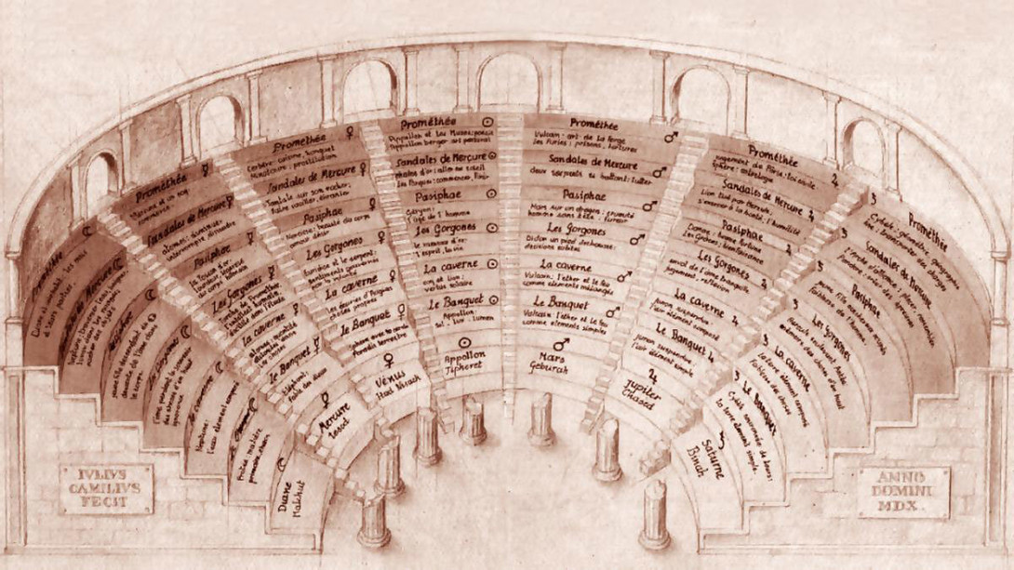
Figure 1. An illustration of 16th century philosopher Giulio Camillo’s vast ‘Theatre of Memory’ used to memorise “everything which exists in the whole world”. Taken from Camillo’s publication ‘L’idea del Theatro’ (The Idea of the Theatre).

How does it work? A worked example of the memory palace technique
To help us better understand the technique, and how we may be able to use it ourselves, the four-time USA Memory Championship champion Nelson Dellis described to National Geographic the construction of his memory palace that enabled him to later memorise the random order of a deck of cards in just 63 seconds.
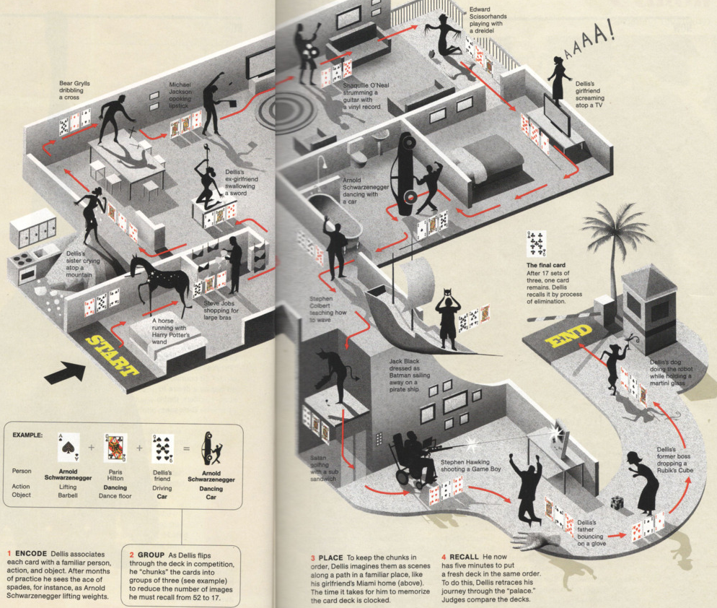
Dellis begins by encoding all 52 cards in the deck as visual representations to be placed in the loci of his memory palace; he does this using the ‘Person-Action-Object’ method of visual encoding, in which to-be-remembered information is visually represented as a familiar person performing an action with an object. For example, Dellis describes visually representing the ace of spades as Arnold Schwarzenegger lifting a barbell. This process is then repeated for every card in the deck. Given the high volume of cards to be remembered, Dellis simplifies the process by combining every three successive PAO card representations into a single one, using the person from the first PAO, the action from the second, and the object from the third. This is known as chunking, a process used to reduce the number of visual representations, and thus loci, needed to memorise and commit high volumes of information to the memory palace. Thus, Dellis reduces the number of required visual representations from 52 to just 17. After completing the visual encoding stage, Dellis then places the 17 visual representations in rooms (loci) on a route through his girlfriend’s Miami home (see Figure 2 for an explanatory illustration of this). Upon being asked, Dellis was then able to recall the order of the shown deck of cards by mentally walking through the Miami home and observing the placed visual representations.
Figure 2. A visual illustration of the memory palace constructed by champion Nelson Dellis to memorise the order of a deck of cards in the 2011 USA Memory Championships; taken from National Geographic March 2012.

Why does it work? The science of it
While the cognitive and neuroscientific basis of the memory palace technique, or MOL, is still not fully understood, the MOL is believed to initiate the process of ‘elaborative encoding’- a process by which a new memory becomes associated with an older established memory. This encodes the new memory into the long-term memory (LTM), thus enabling it to be more easily recalled. In the case of the MOL, elaborative encoding occurs as the visualisation of the new memory item becomes associated with the older memory of the familiar spatial environment.
Furthermore, users of the MOL exhibit specific brain activations in the right posterior hippocampus. Previous research proposes that the hippocampus creates a spatial framework in which all of an individual’s memories and experiences are located. Given this, it is unsurprising that the MOL seems to work effectively by utilising a relationship between memories and spatial environment as the hippocampus itself does. Thus, when constructing and using a mind palace, the hippocampus activates to facilitate the elaborative encoding of the new memory through its association with the old spatial memory in the spatial framework. Although, these conclusions are not fully verified.

The memory palace in the real world
Those familiar with memory palaces in media are likely to envision a hyperintelligent detective or polymath entering the recesses of their mind to retrieve some piece of obscure information that saves the day just in the nick of time. While the technique is perhaps not quite as dramatic as the movies show, the memory palace technique has proven effective across a range of real-world situations. Some applications are unsurprising, such as the ability to efficiently count cards and gain advantage in gambling games such as poker and blackjack. Memory palaces may also be used by students to optimise studying, for example a medical student may use a memory palace to memorise a wealth of human anatomical terminology.
Some applications are perhaps more surprising. One study documents the use of the memory palace technique to reduce clinical depression by improving recall of self-affirming autobiographical memories in depression patients; this recall is normally impaired in depressed individuals. Individuals learning foreign languages may also benefit from using a memory palace to memorise vocabulary; the technique was famously used by linguist Timothy Doner to gain fluency in 20 languages by the age of 17 through the construction of a memory palace, based on Union Square in New York City.
Broadly, the memory palace technique is real, and can be used to enhance performance in just about any task that requires memorisation. Although some time does need to be taken to grasp the concept of the technique and practice it, anyone and everyone can use this technique to construct their very own memory palace.

References
Bradshaw, G., & Anderson, J. (1982). Elaborative encoding as an explanation of levels of processing. Journal Of Verbal Learning And Verbal Behavior, 21(2), 165-174. https://doi.org/10.1016/s0022-5371(82)90531-x

Camilio, G., & Domenichi, L. (1550). L'idea del theatro dell'eccellen (1st ed.). Appresso Lorenzo Torrentino.

Cicero, M., & Sutton, E. (1979). De Oratore (1st ed.). W. Heinemann.

Cornificius, Q., & Calboli, G. (1969). Cornifici Rhetorica ad C. Herennium (10th ed.). R. Pàtron.

Dalgleish, T., Navrady, L., Bird, E., Hill, E., Dunn, B., & Golden, A. (2013). Method-of-Loci as a Mnemonic Device to Facilitate Access to Self-Affirming Personal Memories for Individuals With Depression. Clinical Psychological Science, 1(2), 156-162. https://doi.org/10.1177/2167702612468111

Doner, T. (2014). Breaking the Language Barrier - Tim Doner. TEDxTeen. Retrieved 9 March 2021, from https://www.tedxteen.com/talks/breaking-the-language-barrier-tim-doner.

Glass, N. (2012). Mental Athletes Increase Brain Size in 15th US Memory Championship. National Geographic Society Newsroom. Retrieved 7 March 2021, from https://blog.nationalgeographic.org/2012/03/28/mental-athletes-increase-brain-size-in-15th-us-memory-championship/.

Maguire, E., Valentine, E., Wilding, J., & Kapur, N. (2002). Routes to remembering: the brains behind superior memory. Nature Neuroscience, 6(1), 90-95. https://doi.org/10.1038/nn988

O'Keefe, J., & Nadel, L. (1979). The Hippocampus as a Cognitive Map. Behavioral And Brain Sciences, 2(4), 520-533. https://doi.org/10.1017/s0140525x00064256

