180019899
PS3022 – Lesson Plan Assessment Criteria Feedback Sheet
Criterion | 7-10 | 11-13 | 14-16 | 17-20
Learning objectives building on age-appropriate knowledge | Ideas tend to be pitched at too high or low a level | Some evidence of integrating activity and likely knowledge | Very good evidence of integrating activity and knowledge for both teacher and child | Excellent evidence of integrating activity and knowledge pitched for both teacher and child
An engaging activity | Some points of interest but the writing lacks coherency. | Moderately interesting work but lacking coherence. | Good and cogent work, showing full engagement. | Outstanding response: exceptionally well written and constructed. Excellent coverage of the phenomenon.
Effective learning strategy | No sense of order or continuity. | The piece has a viable design but not a powerful one. | A sound deployment of technique with a pleasing result. | Focused, sustained and excellent management of content.
Engaging use of graphics/language | Language tends towards cliché. No graphics or poor use. | Effective use of language Graphics employed purely as decoration rather than illustration. | Good and engaging use of language and graphics. | Lively and engaging and rich use of language and graphics.
References | Substantial errors both in the content and style of references. | Reference list mostly comprehensive, but failure to use appropriate style in citing references | Referencing generally accurate, though some stylistic errors in the reference list | Generally thorough and proper referencing throughout.
Feedback

Name: ___________________________ Date: ________________

Memory Palace
Our minds are capable of incredible things! Like learning, feeling emotions and creating memories.
What you may not realise, is that our memory cannot remember everything that we experience.
Two types of memory:
There are a number of different types of memory, but today we will be learning about two of them.
Long-term Memory (LTM):
- Unlike STM, it has an endless capacity.
- Information that ends up in your LTM has to go through your STM first, so there are ways to help it get into your LTM
- LTM is where you will find a lot of stories from your past. Maybe like a favourite holiday!

Short-term Memory (STM):
- It has a very limited capacity between 5-9 items (on average 7).
- You can also only retain the items for a short amount of time (at most 30 seconds).
- An example could be remembering the digits of a phone number long enough to call or message someone.

Experiment 1:
For your first task, you are going to LISTEN to a list of 10 words being read to you. Try your best to remember as many as possible. Make sure you are quiet and paying attention as the words are being read to you! Once the list has been read all the way through, write down as many words as you can remember below.
How many can you remember?
?
?
?
?

Total:

How did you do?
Did you get them all? It’s ok if you didn’t! Actually, it’s normal not to remember all of them because you were using your short-term memory. Remember, you can typically only remember 7 items when using your short-term memory.

Memory Palace
Now what’s this whole memory palace lesson about? Let’s get into that now! A memory palace uses your working memory to form a kind of visual map in your head. Now, it doesn’t have to be an actual palace. Think of a place that you know extremely well (like your bedroom or the kitchen in your house). You are going to use the image of that place in your head to help you remember a new set of words.
Here are the steps to making your memory palace:
- Pick a room in your house that you are able to imagine very vividly in your mind.
- Pick 10 items in that room that you will later use to place the words that you are given. If you are able to be in that room right now, go ahead and walk around it.
- Plan a path through the room that brings you by all of the items that you chose. This can be done in your head, or actually in the room if you are able to. Look at the photo below. This is an example of how someone has planned out a walking route throughout the entrance to a home.
- When the new list of words is read out to you, place the words around the room throughout the oath that you created. See if you can pair any of the words with items in your room to make it easier to remember them.
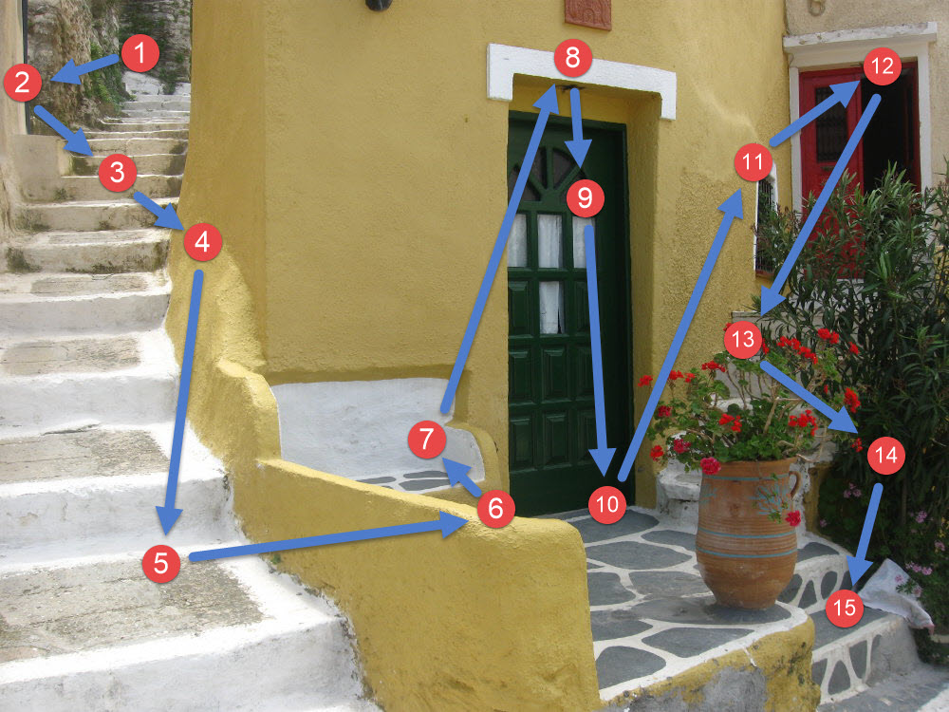
Are you ready to try?
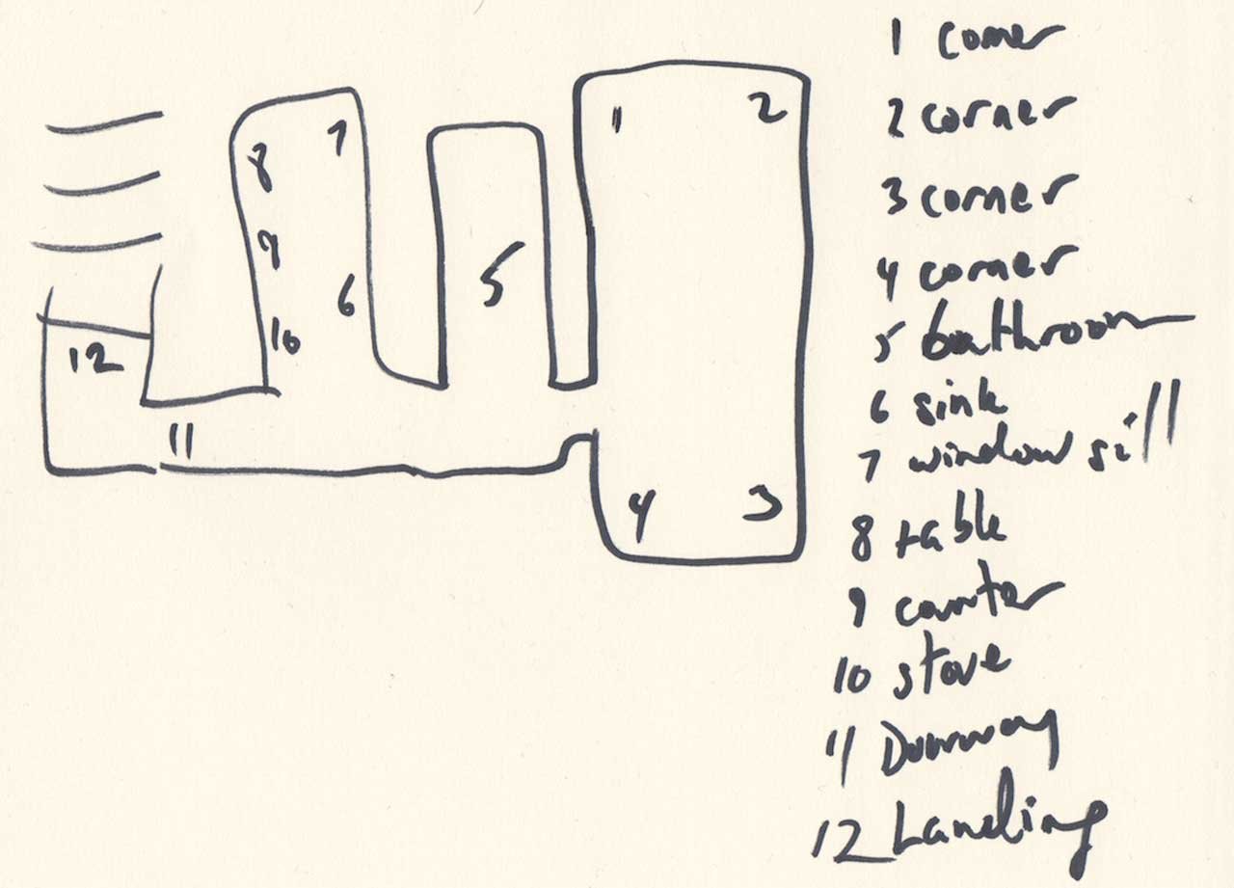
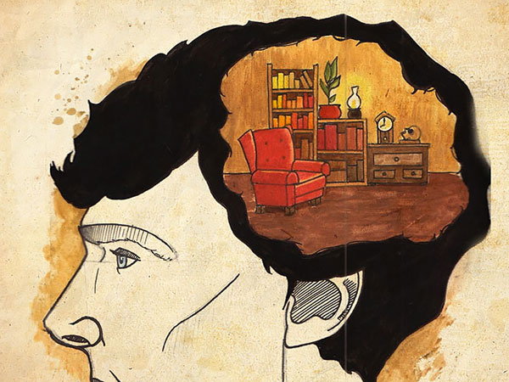
How many did you get this time?
Total:

Did you remember more?
How a
Memory Palace
works
- A memory palace helps to move information from your short-term memory to your long-term memory.
- Using the image/memory of a room that you know very well helps you connect the new information that you have just learned to old information that you have engrained in your long-term memory.
- You are visualising the words in a very familiar place. It is like you are making a story with them that you can play back in your mind to help remember them better than you could when you are only trying to remember a random list of 10 words.
- This is a fun strategy that you can use to help you remember more than just a list of words. You can try it out on the next test that you have!
What have we learned today?
- There are different types of memory!
  - Short-term memory has a limited capacity, so we can only remember around 7 items for no more than 30 seconds. It helps us remember things like phone numbers long enough so that we can call or message someone
  - Long-term memory has an unlimited capacity and is where we store memories like our favourite holidays.
- We can use a memory palace to help us remember things better because we are connecting information from our LTM to the new words.
- We are able to visualise the words in a familiar place which helps to move the words from just being in our limited STM to the unlimited LTM!

Teacher/Parent/Guardian Information Sheet
Setup Information:
This activity can be done from anywhere. A classroom, bedroom, kitchen or even outside. It can be done within a group or just one on one with you and the child. Apart from the worksheet, the only other tool the child will need is some kind of writing utensil.
Attention Grabbers:
To get the kid(s) excited, you can talk about how they’re going to learn a fun new trick that gives them super memory. You can let them know that this is the same way that Sherlock Holmes is able to remember everything, and that people have been doing this since antient Greece!
Conducting the Experiments:
For experiment 1, remind the students that they are not allowed to write anything down while you are reading off the list of words. Only read the list off once and read them with a tiny pause between each to make sure they hear them all. The list of words can be found below. You can also come up with your own list of words if you’d like. After you finish reading the list, wait 20-30 seconds. If you are only working with one student, you can ask them to repeat the words that they remember back to you. They should also write them down in the table provided. Remind them that it is normal not to be able to remember all 10 of the words because our STM has a limited capacity
For experiment 2, make sure that the student(s) have a place in mind for their memory palace. They can discuss this with you can each other, if there is more than one student participating. Ask them why they chose that place. You then read the list the same way that you did in the previous experiment. This time allow them the chance to place the words in the areas around their chosen place. Once they are done with that, ask them to write down how many they remembered. You can then discuss why a memory palace helped them to remember more of the words in the second experiment. I’m sure the students will come up with some fun ideas!
Stimuli:
Here are the two lists of 10 words that you will use for both experiments. These are completely random lists of words and you can come up with your own if you’d like to.
List 1 | List 2
Football | Food
Car | Maths
Hand | Guitar
Glasses | Friend
Scissor | Ocean
Jumper | Brother
Bear | Store
Coffee | Work
Book | Hair
Tree | World

Conclusion:
Hopefully this was a fun way for your student(s) to learn a bit about memory with some little tricks to help them in the future. There is a list of references below with more in-depth information if you are at all interested in learning more about memory palaces and the different types of memory!

Works Cited
McLeod, S. (2021). Multi-Store Model of Memory. Retrieved from Simply Psychology: https://www.simplypsychology.org/multi-store.html
Metivier, A. (2021, February 22). How to Build A Memory Palace: A Scientifically Proven Approach. Retrieved from Magnetic Memory Method: https://www.magneticmemorymethod.com/memory-palace/
Peeters, A., & Segundo-Ortin, M. (2019). Misplacing memories? An enactive approach to the virtual memory palace. Consciousness and Cognition.
(2017) Sherlock Holmes Brain Illustration. Chess News. https://en.chessbase.com/post/memory-techniques-memory-palace-from-roman-times-to-today
(n.d.) How to Build a Memory Palace. Memory Techniques Wiki. https://artofmemory.com/wiki/How_to_Build_a_Memory_Palace

