Faces in the clouds?
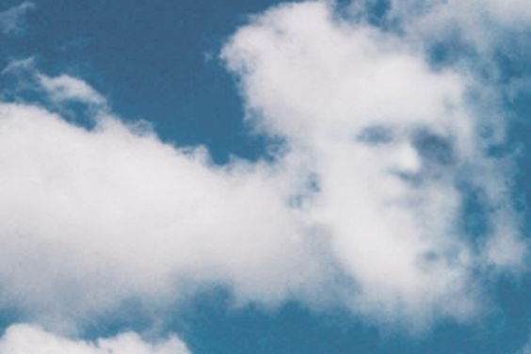
At first glance, you may only notice the clouds in figure one. However, upon second look, you may see a face within the clouds. You may have the ability to notice faces in a variety of everyday objects. Perhaps you have passed a house where the windows look like eyes and the door a mouth, or maybe you have seen a face in the pattern of a dress. This phenomenon is known as face pareidolia.
Figure one: Facial pareidolia noticed within the clouds. Posted by a user on Pinterest.
This sensation is described as finding face-like structures in everyday objects and assigning human characteristics to them. One suggested theory to explain this is because it is advantageous in evolution. Evolutionary psychologists believed it was possible that our ancestors used pareidolia to improve their chances of survival. Carl Sagan suggested that if babies struggled to recognise faces, they would react less to their parents and would fail to win over their love. Therefore, if pareidolia was present, they could recognise faces and win the hearts of their parents, making them more likely to thrive in their parents’ care.
Furthermore, distinguishing between friend or enemy as well as determining the emotional states behind faces would have been beneficial for our ancestors to protect themselves from predators. Knowing if someone is angry at you is always a good thing, even in the modern world! If our ancestors could spot faces easily in the area surrounding them, it would allow for a quicker get away from a threat. This would enhance their chances if survival and so we can see how face pareidolia has evolutionary benefits.
Dr Tsao, a neuroscientist, proposed that we prefer faces over patterns. She noted that cells in the brains of macaque monkeys would activate when shown images of faces and would not respond to images of objects. She also noticed that these cells are not perfect and that objects may still weakly trigger these cells. Cognitive scientist, Dr Sinha used computers to research pareidolia and agreed with Dr Tsao, that our brains are sophisticated enough to discover facial patterns. However, it is not flawless, and objects can satisfy the requirements of our cells. Dr Palmer suggested that face pareidolia is a kind of visual illusion. This is because we can’t help but see an object as having ‘mental characteristics’ such as a direction of gaze, because of these cells that detect objects with face-like features.
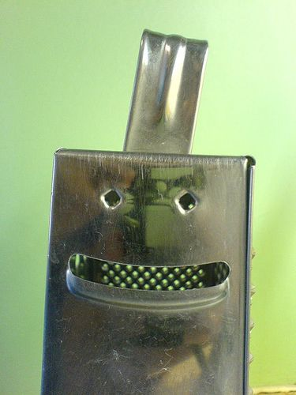
This preference for faces can also be seen in babies, suggesting that we naturally look for faces in anything, even objects. Scientists were able to show that babies were immediately attracted to faces from birth. They were able to do this by showing babies two images, with one looking more like a face than the other. They measured where the baby looked and found that the image in closer resemblance to a face was paid more attention to. Babies will usually stare at a face for longer and more intently than anything else they see.
Figure two: Posted by a user on Pinterest who noticed face pareidolia on a cheese grater.
Face pareidolia can also be described as finding patterns within everyday objects. Neurologically, there are two possible reasons for this ability to find patterns. The first is that our brains are organised in a way that allows us to process large amounts of information at the same time. Being able to process information side by side helps to find patterns, make associations and work through data. Secondly, perception is involved in constructing an idea in your head. That means that when you process an image, you will go through the data information you already have in your brain and attempt to find the best match for the image. For example, three holes in a cheese grater match the pattern of eyes and a mouth, therefore your brain will associate it with a face and will fill in the missing details to enhance the picture.

Figure three: Example of an inkblot from the Rorschach test.
Face pareidolia can be seen in real life applications. Some psychologists rely on this phenomenon in examinations. A test known as the Rorschach test can be used to examine a person’s personality characteristics and emotional functioning. This test may also be known as the ‘inkblot’ test. Typically, ink is dropped on a piece of paper which is then folded in half. This image created by folding the paper is then shown to the patient. The psychologist would then ask the patient for their interpretation of the inkblot. It is believed by some that whatever the patient sees, which could be a face made from this random image, may reveal the inner thoughts and feelings of the patient.
Face pareidolia is a fun psychological phenomenon that can be seen in everyday life. There is not a definitive answer for what causes this sensation. All we know is that it is a common occurrence, that you might have been unaware had a name when you were searching the clouds to make faces and shapes. From now on, you can keep an eye out for faces in your normal routine. You could even attempt the Rorschach test yourself and see what you can make from the images and brainstorm what it could mean!

References/bibliography
Figure one: https://www.pinterest.ch/pin/168110998570622064/
Figure two: https://pixels.com/featured/1-rorschach-inkblot-testcard-2-erzebet-s.html
Figure three: https://www.pinterest.es/pin/634515034979499274/
http://www.sci-news.com/othersciences/psychology/face-pareidolia-08752.html
https://www.lenstore.co.uk/eyecare/pareidolia-science
https://www.inverse.com/article/49527-what-is-pareidolia
https://www.artsy.net/article/artsy-editorial-human-faces-look
https://kids.frontiersin.org/article/10.3389/frym.2017.00067
https://neurosciencenews.com/object-faces-16827/

